LOOKSHOW

Second try, all in one go,   
First 12 paragraphs up to fort/Da  
unmoORED Likely turning into video?online presc enses

Para one TURNS INTO A SHOT OF FLAPPING BEDSHEET; IMAGE FIRST TRAIN BY MURRAY

Dirty laundry. Build a clothesline, posts 12 feet apart that look like crucifixes, Barnabas and the other guy with the pulleys coming out of their bellies to hang the bed sheets on the bed sheets are white. Jesus got away. The bed sheets can flap the bedsheets can sound like they are flapping the sheets can be tied down for screaming/screening.

Para two

On the brick wall. Project handicapped simple. That's a mistake of my mind. Symbol project handicapped symbol. I am worrying my neurologist did not pay enough attention to my scan or my medical history dismissing me too easily yesterday.

Para 3  
Heavy metal door. A dent, graffiti. The yellowish light from gray barnyard lamp reveals one of the graffiti to be an Angel trying to push themselves through the door but the wings won't go.

Para 4

Jacob's ladder. The door opens into an entirely new universe overgrown with a big tree in the middle of it and stairs Hewn into the bark barely accessible to even the most capable of climbers. There are doors off to one side and the other of the tree for the different levels of the building each landing has a story a very short 32nd video

Para 5

landing one Fort/Da. Video monitor with a child throwing a (plastic) baby bottle into a wall. There is enough room on the landing for a basket of stuffy toys so that people can throw them against the wall if they wish to produce the bait.

Para 6   
landing two shitty cunt piss .Monitor with a girl playing with a truck or tractor rolling them back and forth saying shitty cunt piss shitty cunt piss. Over and over and over.

Para 7  
landing three "Ich Will Rein!" (German) a little boy is hammering on a vintage white door with glass in it pounding and pounding shouting!ch Will Rein! we hear faintly a piano.

Para 8   
Landing 4 Burn down the House. Boy reaches for a vintage mother. Her dress catches fire. She turns to ashes a heap of ashes. See poem Burn Down the house.

~~Paranoid landing 5~~. You're pulling my leg!   
para 6 actually it's if 6 was 9 it is   
para 9 and landing 5 an operating theatre in the video a video monitor operating theatre a leg being amputated. para 9 - You're pulling my leg!

para 10 landing 6 Lookshow, Listenhere. Glasses and hearing aids. Nothing to click away to see which is better, hearing aids much the same but on video again in 30 seconds. Possibly young boy opening the box glasses come in in the mail and putting on a pair of glasses and smiling in his striped boy shirt. The hearing aids would be the 2nd 15 seconds and they would be impossible to fit properly lots of feedback as noise distortion in the first one until everything is clear as digital.

para 11 landing 7 "Spiel Mir Was." (German) we've made it. One last monitor and you open the door and step inside the gallery. SPEIL MIR WAS poem.

SO A TODDLER BED, STRAIR RAILINGS, MUSIC FROM CLAIR DE LUNE LOOPED

You throw open the damn door, and we hear for today anyway. FERRY apostrophe ask the musician Bryan Ferry's version of the Neil Young song which has the chorus like a hurricane I had a big flashlight LIGHT FIRE EXPLOSION and you're in the gallery. The lights dim as you step across the transom



SO FAR BY NOON March 4 (Revised March 5)

2 pm March 4 (Revised March 5)

Installation one - Who Are You

Field typewriter. Set up and working. Please type your name. Thank you for visiting the look show. There is a DVD player on the extension of the field typewriter which is attached to the first screen and screening opportunity. Short loops only. And each screening should provide some foreshadowing or direction to the next one. This is the only piece ready for lookshow. It's a "ready made." Found by Michelle Hewitt.

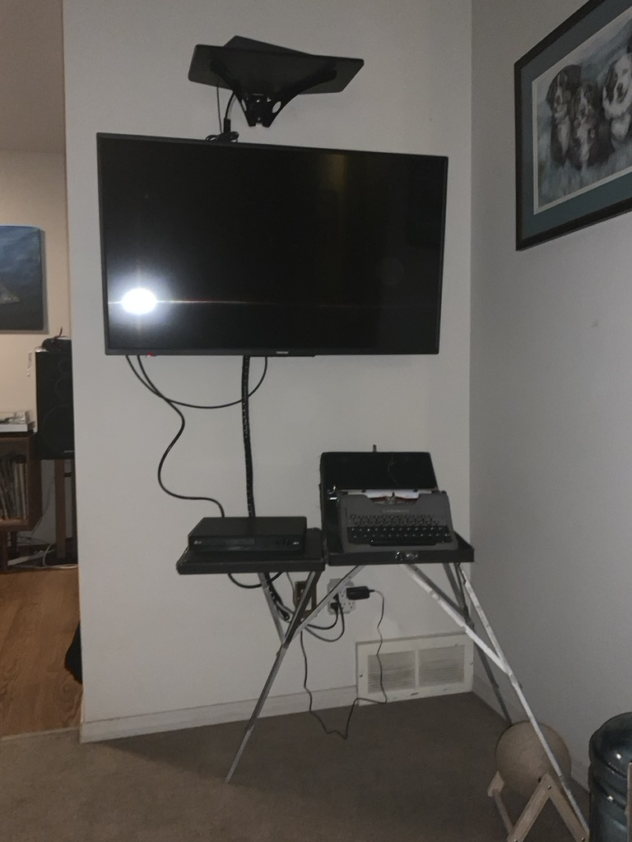

Installation TWO - What's going on here? Discovery Strips  
 There are three doors hung from the ceiling against the wall the far wall.  
 By Murray Toews.

The bottom two should be readable by someone in a wheelchair the top one would need to stretch. Ideally there would be pulleys unchains and people could raise and lower them according to their needs. So those are three doors what's behind door number one and door number 2 door number three? Well it's not actually let's behind the doors it's what's on the doors. This is Murray taves his show and there would be three to four panels available for story or graphics or Dada or the German expressionism we both like George grows at Max erenst those kinds of things but perhaps presented us comic strips but very artful comic strips or a graphic novel this is really up to Murray for whatever he can do is 3 doors on the horizontal for a period

INSTALLATION THREE - MY SKIN AND BONES With LIEF NORMAN and hoppefully MEDICAL MRI

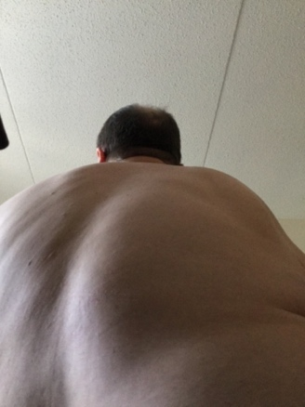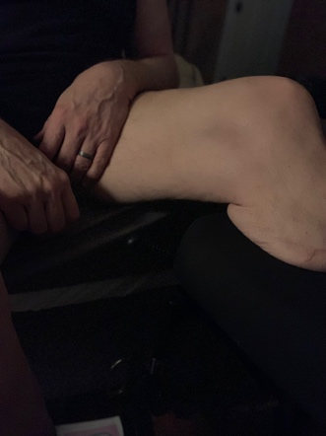

Naked picture of me and my skin. By Victor Enns, Richard Hines, Michelle Hewitt.   
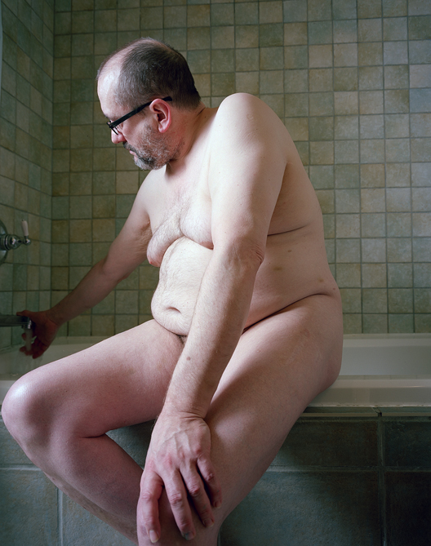Large photo print framed in a metal standard type frame is have a poem that goes exactly with that "Camera Shy" that I could add to the end of this because it also talks about the dragon dogs the dark dogs the paradox paradogs and then we would have my knee disappearing into the bed in the dark with my ring finger showing against my black blackened crotch, we would have one of my back side shot as to how fat or obese I am new to put that on display and then there is one more so those four would be structured as if they were in a window with four panes the traditional farm for pain window frame to hold those smaller images of my skin

BONES: We have lightboxes. Next to the skin to two at least maybe three or four depending on space and how this would work they would be xrays or scans of my neck my back my hands and my ankle. And outside of the Richard Hines photo most of them are Selfies so this is by victor hands like the first one is by Murray Toews.

INSTALLATION FOUR - Brain bang

We have a high striker. This installation is to the left of skin and bones with brain replacing the bell at the top. People will be provided with a hammer and will be allowed to slam the pack up to bang the brain.

INSTALLSTION FIVE - where the light gets out.

We have (broken?) sconces, by Grace Nickel; relevant to my heart and spine issues.

on each side of the pain room door.

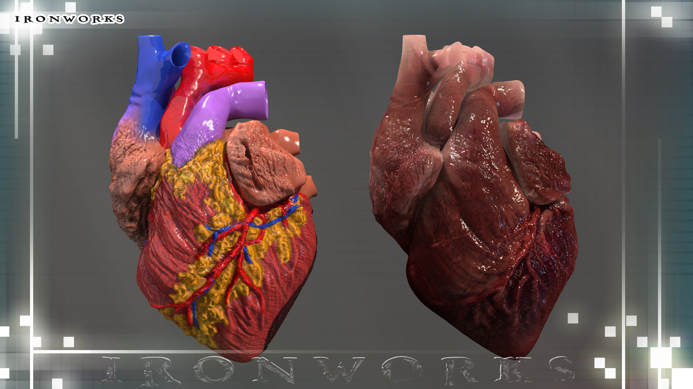

MY SLIGHTLY DEFECTIVE HEART

*for Peter Dueck, Chrissie Hynde, Grace Paley, Les and Jane*

My heart is irregular and incompetent, still it keeps beating

all the time. Arrhythmia is what it’s called, that flutter,

that irregularity. My friend said “just imagine, you’re a lucky man, you have a butterfly heart.” I’m sure his job doesn’t let him use enough metaphors, and I enjoy the thought, lightening up.

Oh so much better to have a butterfly fluttering in my chest.

My heart’s incompetence is the incompetence of my aortic valve.

I swish I swash, my heart sounds like an old washing machine.   
Listening, my general practitioner heard the sluice back  
using his stethescope. Yes, sir, confirmed the ultrasound.

Cradling my heart in my hands I urge all this blood

to keep circulating, a deep breath, my life assured

Astride a chair at the East Interlake Klean-All Laundromat.

I swish, I swash, watchin the clothes go 'round, beat that.

INSTALLATION SIX Pain Room

Room with a ragged door and a pain room sign on it like the illustration that are 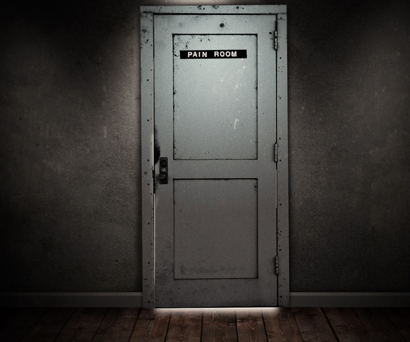graphic that Murray has already done a period there is a slot that you could move back and forth and again if you were to make this an interactive video that was that would be something that you can do say if you rang the bell you got to move the slot and if you move this slot open ypou see the sculpture by Ken Gregory and some rapid drumming by Chris Mama Bauer every time the slot opens inside the pain room you see the tire belt spike spike bell that's what they're called the entire spike belt ah to serve with this culture as the broken vertebrae are the vertebrae of the person in pain on his back. MURRAY TOEWS' picture or larger redraw SHRAPNEL is featured in the room. We could ask Giles Hebert to donate some of his knick knack paddy whack.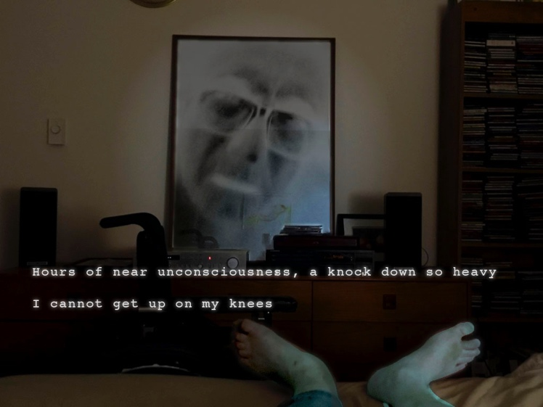whacks in a shelf in the room.

INSTALLATION SEVEN

Tire Spike Belt + ironworks vertebrae by Ken Gregory. Please note this is an illustration of a loom that I liked looks a bit like a rack. A place holder until I get an illustration from Ken.

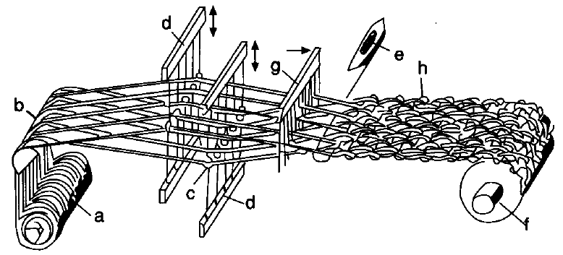

INSTALLATION EIGHT - BookCart

We have a library book cart. Each installation has bibliography with as many books that we can find that were part of the inspiration for the show possibly to serve instead of labels. Anyway this would circulate and it could be positioned and moved around from one exhibition from one installation to another.

INSTALLATION NINE - Bed-Ridden   
 We insert video screens into a hospital bed that can be raised up or down with any luck. Here we run Murray's videos or any that have to do with being in a hospital bed some of which still would probably need to be made. But there is a store of existing material I think. I thought of making one of them into the pain room and that could work if we were short on space but if this is a virtual exhibition then we can have the pain room and three beds.

INSTALLATION TEN - Fatigue  
We have art on bed sheets ... We ask for submissions of artwork representing fatigue, or Commission a specific artist with an interest, (A vacant head trailling unattached wires on a pillow?) with that would run the length of a hospital bed in Bay number 2.

INSTALLATION ELEVEN Everything Slips me away  
 A sound installation in Bay 3 We have a voice over voice over of my mother speaking that phrase in low German that is essentially everything slips away from us and being dropped. So sound crossed from her voice (I may have on audiop), or a female voice, with the sounds of dropping knives, spatulas and a glass shattering.

INSTALLATION 12 Angel Time

We have an Angel Sculpture trying to leave the hospital bed by the way of the ceiling and is stuck because he can't get up, can't get his wings through. THE END  
THIS JIMMY BANG'S ANGEL TIME

The final stop for visitotrs.

We have a transparent still under a cylinder maybe with a bit of copper on it as a joke with a manuscript inside which says look show on it and is the book of the show catalog ideally I'd like to find a way for a person to experience this on their own alone listening to Leonard Cohen sing avalanche or I came so far for beauty you could change those two songs you'd have to get rights I think to play them add they'd be on a loop and there'd be the book and you press a button an at prints for you OK laugh laugh laugh laugh

MERCH: White Crying towerls, maybe with grommets for golf bags with ther words in envoi fount saying

*cry  
cry*

*cry*

ENDNOTES & ACCOMPANYING POEMS

Burn down the house

I run.

Black and white

speed boots raise dust

from the acre garden,

me with nowhere to go

but back in the house.

Mother better

be there. I see

her now. She tugs

the Electrolux.

I slam

the outdoors

behind me,

reach hungrily

to mum

i this is not goodn that floral

print dress

again. She moves to me

this time, catches fire.

I see

her now

nothing but fire

between us,

ashes

I remain.

CAMERA SHY  
 *To photograph is to confer importance.* – Susan Sontag

1.  
The photographer knocks, and I say come in.   
My face does not know what to do in front of a camera;  
my body long past  
caring; only the surgeons,  
planning their cuts, need to know.

2.  
My angry fascination with the abyss,  
with the edge, cutting or leading,  
comes to this; I sit on the ledge  
of the soaker tub, swing my legs  
into the hot blue water, my back  
hunched, my hands on the grab bars  
lowering a body mass index close to obese.

3.  
The photographer breaks up  
with me, an inadequate subject  
my face empty of expression  
or nuance, nothing going on  
the lens can see, no conflict

cameras attracted to danger,   
nothing doing here,   
my vacancy a flat effect,   
only I feel the black dog paratroopers   
drop behind my eyes.

**Spiel mir was**

says my dad to my sister

never father to me, always

dad without a capital my sister

always two sibilant syllables

at the piano, dad stretches

out on the couch

play me something, says my dad

one arm cast over his eyes

on the other hand, he fits

temples between his fingers

laying his glasses on the linoleum

my sister plays a waltz of Chopin

a bit of Bizet's Claire de Lune

Mozart’s sonatas of stars and C

a lullaby of Brahms. I fall

asleep in my bed listening

from the top of the stairs

**Jimmy Bang’s Angel Time**

I’ve been fat and I’ve been thin

Even believed in Original Sin

But I’ve been traveling Angel Time.  
I’ve gone to bed with a sharpened knife

I’ve been married and lost my wife

But I’ve never been arrested for a crime.

I’ve dropped acid and smoked dope

Hung myself with a rubber rope

But I’ve kept travelling Angel Time.

I’ve lost fortunes in my head

Been to hospitals and declared dead

Watching God talk pantomime.

I drink whisky I drink beer

Cowboy Space is getting near

I’m gonna travel Angel Time.

Not gonna worry not gonna die

‘Cause if that Angel Time don’t fly

I’m gonna buy me a nursery rhyme.