Clean shirt dear writer within, a white shirt with orange and cherry jam stains, but properly buttoned. You weren’t ready for anything this morning. I wasn’t ready for anything this morning, except a thorough sponge bath out of my new basin that overlaps my lap. My new medicine chest (I have many medicines) arrived this morning and will be installed by our carer this afternoon. Time is 2:10. Ten minutes wasted on getting started.

And here’s some time to claim about my pain is pain is pain. is too painful to write down properly. To “claim” about is a significant cognitive variance, as the word complain was the desired word, just not desired enough.

I will die. But surely not today.

“The pleasure of the text is that moment when my body, when it pursues its own ideas -- for my body does not have the same ideas as I do.” (17 Pleasures of the Text, Barthes)

My brain pursues fragments with fervor, my body is rarely aware of where it is, reminded when I am wounded, or set on fire.

My anger when I shout out fully loaded with pain at the intellectuals and ani-intellectuals
who laugh at my sentences and misguided secrets deriding my punctuation. I am reading but the still remains. My cat rests like this, on the claw sharpening carboard.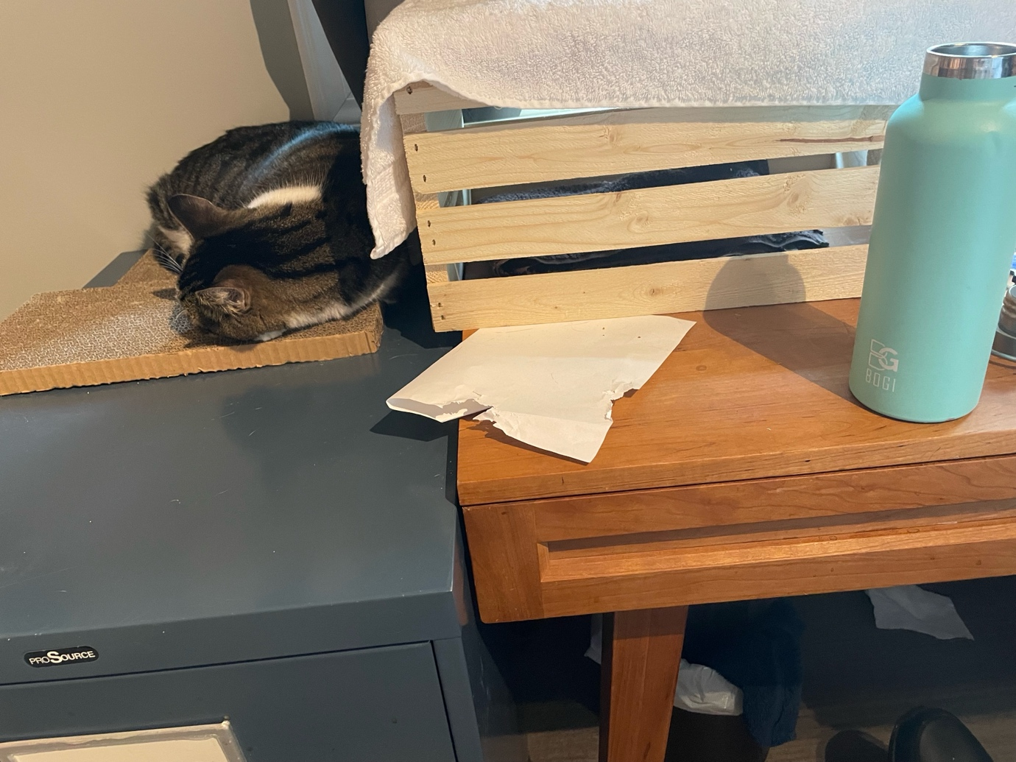

Body’s choice first out brain searching for the word “period.” My shoulders finds pain.

